Sunday Services
at St Michael’s Church, Boldmere
September to December 2021
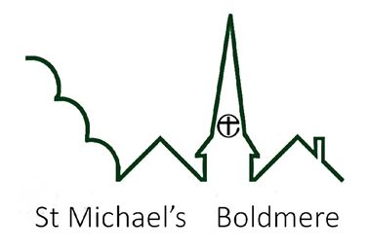
All of us are welcome

Date | Morning  10.00am | Evening  6.00pm
5th September | Holy Communion | Reflective Service
12th September | Holy Communion | Service of Lament and Hope
19th September | Holy Communion | Breathe
26th September | Harvest Festival | Holy Communion
3rd October | Holy Communion | Reflective Service
10th October | Holy Communion | Reflective Service
17th October | Holy Communion | Breathe
24th October | Holy Communion  Everyone Together | Reflective Service
31st October | Holy Communion  Everyone Together | Memorial Service
7th November | Holy Communion | Reflective Service
14th November | Remembrance  Service | Holy Communion
21st November | Holy Communion | Breathe
28th November | Holy Communion | Waiting on God
5th December | Holy Communion | Reflective Service
12th December | Holy Communion | Breathe
19th December | Nativity Service | Holy Communion
Christmas Eve |  | Carols and Crib  4.00pm  6.00pm
Christmas Day | Holy Communion
26th December | Holy Communion
+Night Prayer on Zoom at 8.00pm most Sundays

